Renju lesson on April 19, 2001

Hello all! Welcome to Online Renju Class. Today we will learn the popular variants of d11 opening. last time we learned about 11th moves. Today we will learn about the strongest 11th move. Do you know where is the best 12th move? Do you know which 12th moves are possible? Let me speak few words about the history of this main variant. According to the old theory, everybody used to play 12-g6. It was considered to be the best 12th move. About 10 years ago, white won most games with 12-g6. Then, around 1997 the strong developments were found for black there. By the year 2000 black won most of games after 12-g6. That made people search for better 12th moves. Within past 6 months two new 12th moves became popular. Do you know which ones? Not that during the 1997 WC 12-j9 was often played too, but it was quite hopeless move. Black won too easily. Moves k12-k7 and 12-h10 are the new moves. Those moves are so interesting and good, and they put black advantage in this opening under the question. Despite the serious analyses, I have not been able to prove black win or serious advantage here yet. Not yet. In the old times, people thought that it is dangerous to leave g6 point open. They were afraid of black possible developments in lower side.
Lets take a look at old theory first. G6 please.
Move 13-f7 - a classical answer in Japanese soft style. 13-f7 was considered to be the best move for maybe over 20 years. However, white gets the advantage here. 14-h10.
See of the variant has been developed up to 32nd move. The moves are all old and traditional. These 32 moves were often played in the old times. Maybe it occurred in hundreds of games all over the world. White won in most cases. Usually black continued in passive defense. Lets see what happens if black plays actively.
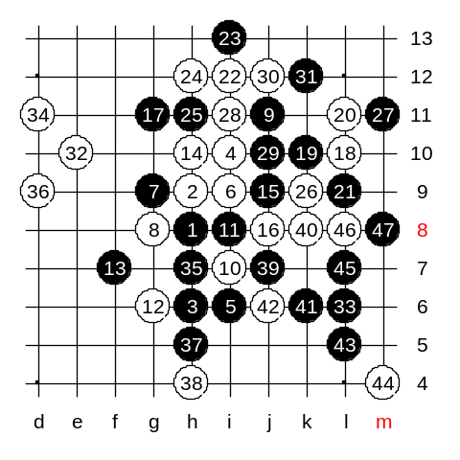
Black cannot make any good VCF threat now. So, black can only attack by using control style. White cannot win just by using g12 and f10 points. White needs d11 point to win on the left side. Therefore, if black could only control the h7 point, then white cant win. Now, how to control h7 point? Remember! Controlling a certain point doesnt mean that we must play a stone into that point, or even nearby it. It is enough if we make a move elsewhere, knowing that later of we get a stone to h7, then we have VCF threat. Move L6 helps to control h7 point. Lets play it out, then you see clearly.

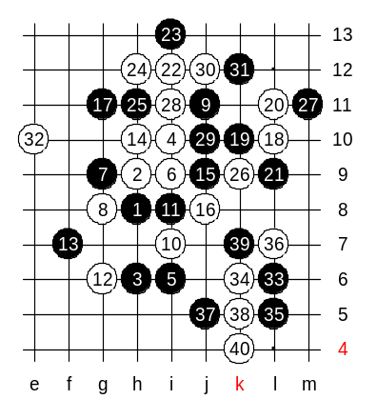
Now you understand the idea of control style. Black did not play passively in defense, but used active L6 to defend white. Now important rule: "You should fight for getting the tempo ONLY when you have something useful to do with it." Move L6 is actually a bad move, but why? Because white can now just continue passively in defense for a while, and after blocking everything, white can enjoy the attack on the left side. White plays passively k6. Now d11 is alive again. Black plays L5 and still controls the h5 point. But this is just prolonging the agony. Black is about to die soon. White plays L7. Now black goes j5, and yet controls h7, right? But now, white k5, and white VCF threat inside position.
Now there are 40 stones on board. Black area has been wasted. And black must go to defend left side having no chance to win this game.

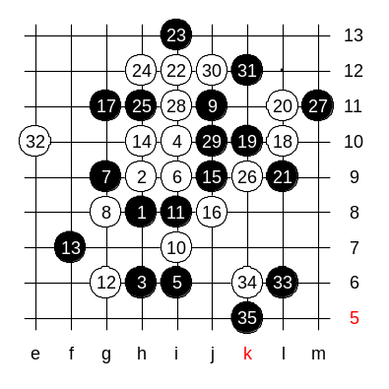

This is the medium level homework. Please find the white win.

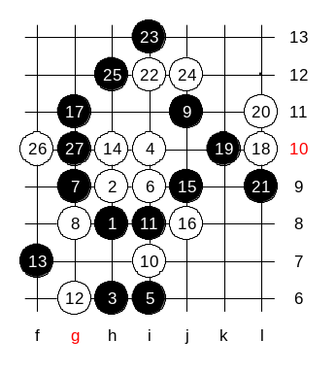

This is the advanced level homework. Please find white win (if it exists).

